Book

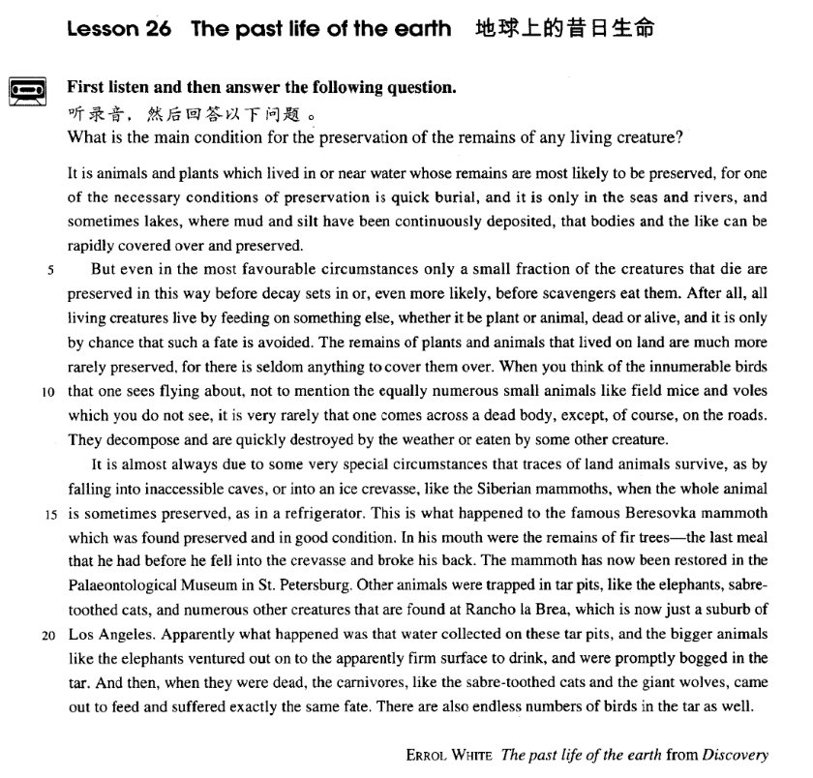

课文

It is animals and plants which lived in or near water whose remains are most likely to be preserved,

只有生活在水中或水边的动植物尸体最有可能被保存下来，

for one of the necessary conditions of preservation is quick burial,

因为保存的必要条件之一是迅速掩埋，

and it is only in the seas and rivers, and sometimes lakes,

所以只有在泥沙不停淤积的海洋和江河里，有时在湖泊里，

where mud and silt have been continuously deposited, that bodies and the like can be rapidly covered over and preserved.

尸体之类的东西才能被迅速地覆盖而保存下来。

But even in the most favourable circumstances only a small fraction of the creatures that die are preserved in this way before decay sets in or, even more likely, before scavengers eat them.

即使是在最有利的环境中，死去的生物中也只有一小部分能在开始腐烂前，或更可能在被食腐动物吃掉之前，被这样保存下来。

After all, all living creatures live by feeding on something else,

因为一切生物都是靠吃别的东西来活命的，

whether it be plant or animal, dead or alive,

不管这种东西是植物还是动物，死的还是活的，

and it is only by chance that such a fate is avoided.

因此，生物偶尔才能避免被吃掉的命运。

The remains of plants and animals that lived on land are much more rarely preserved,

曾在陆地上生活过的动植物的遗体被保存下来的更为罕见，

for there is seldom anything to cover them over.

因为陆地上几乎没有什么东西覆盖它们。

When you think of the innumerable birds that one sees flying about,

你可以想象出天上有看得见的飞来飞去、数不清的鸟，

not to mention the equally numerous small animals like field mice and voles which you do not see,

地上有不显眼的无数的老鼠和田鼠之类的小动物，

it is very rarely that one comes across a dead body, except, of course, on the roads.

但是，除非在路上，很少有人遇到这些动物的尸体，

They decompose and are quickly destroyed by the weather or eaten by some other creature.

因为它们腐败之后很快就被风化掉，或被别的动物吃掉了。

It is almost always due to some very special circumstances that traces of land animals survive,

几乎总是由于某些特殊的条件，陆地动物的遗体才被存下来，

as by falling into inaccessible caves, or into an ice crevasse, like the Siberian mammoths, when the whole animal is sometimes preserved, as in a refrigerator.

如掉进难以到达的洞穴，或掉进冰河裂缝里，或者像西伯利亚长毛象那样掉进冰窟中，有时整个动物像被放在冰箱里一样被保存下来，

This is what happened to the famous Beresovka mammoth which was found preserved and in good condition.

著名的那林索夫卡长毛象就是这样被保存下来的，而且保存得很好。

In his mouth were the remains of fir trees -- the last meal that he had before he fell into the crevasse and broke his back.

它嘴里还留着冷杉 -- 它掉进冰河裂隙折断脊椎柱之前的最后一顿饭。

The mammoth has now been restored in the Palaeontological Museum in St. Petersburg. Other animals were trapped in tar pits, like the elephants, sabre-toothed cats, and numerous other creatures that are found at Rancho la Brea, which is now just a suburb of Los Angeles.

这头长毛象已被修复，现存于圣彼得堡古生物学博物馆。有的动物掉进天然沥青坑里被保存了下来，如在兰桥·拉·布里——现在是洛杉矶的郊区发现的大象、剑齿虎和许多其他动物。

Apparently what happened was that water collected on these tar pits and the bigger animals like the elephants ventured out on to the apparently firm surface to drink, and were promptly bogged in the tar.

显然，事情的经过是这样：沥青坑里积存了水，大象那样的大动物冒险到似乎坚固的水面上去饮水，立即掉进了沥青坑。

And then, when they were dead, the carnivores, like the sabretoothed cats and the giant wolves, came out to feed and suffered exactly the same fate.

大象死后，一些食肉动物，如剑齿虎和大灰狼就来吃大象，结果遭到了同样的命运。

There are also endless numbers of birds in the tar as well.

沥青坑里还有无数只鸟的尸体。

词汇讲解

Lesson 26

**The past life of the earth**

preservation [7prezə'veɪʃn] n. 保护，保存

preservation n. [U] when sth. is kept in its original state or in good condition 保护，保存

building / environmental / food preservation

preservation of …

the preservation of our cultural heritage

conservation n. 1. [U] the protection of natural things such as animals, plants, forests etc. 保护（动植物，自然环境等）

wildlife conservation

conservation of the countryside

conservation n. 2. [U] when you prevent sth. from being lost or wasted

保存

energy conservation

reservation n. 1. [C] an arrangement for a seat on a plane or train, a room in a hotel, etc. to be kept for you 预定

I'll call the restaurant and make a reservation.

reservation n. 2. [C, U] a feeling of doubt about a plan or an idea 保留意见

I have serious reservations about his ability to do the job.

The old building is in a good state of except for the wooden floors.

*(CET6)*

(A) observation (B) preservation

(C) conservation (D) reservation

scavenger ['skævɪndʒə(r)]

n. 食腐动物scavenger n. 食腐动物vertebrate n. 脊椎动物

invertebrate n. 无脊椎动物mammal n. 哺乳动物primate n. 灵长类动物rodent n. 啮齿类动物marsupial n. 有袋类动物crustacean n. 甲壳类动物biped n. 两足动物quadruped n. 四足动物

prey n. 被捕食者，猎物

predator n. 捕食者

decompose [7di:kəm'pəʊz]

v. 腐烂

decompose v. to decay or make sth. decay 腐烂

Fallen leaves gradually decompose.

The fertilizer releases nutrients gradually as bacteria decompose it. rot / decay

Too much candy will rot your teeth / make your teeth rot.

Too much candy will decay your teeth / make your teeth decay. Each civilization is born, it culminates, and it decays.

impose v. 强加

expose v. 暴 露propose v. 建议，求婚oppose v. 反对，对抗dispose v. 布置，安排

interpose v. 插入，介入depose v. 罢免，废黜compose v. 组成，构成decompose v. 腐烂，分解

transpose v. 使互换位置

juxtapose v. 将……并列

inaccessible [7ɪnək'sesəbl]

adj. 难以到达的，无法到达的

inaccessible adj. difficult or impossible to reach 难以到达的，无法到达的

The country consists mainly of dense jungles and inaccessible mountain ranges.

The bathroom is situated at the top of a flight of stairs, making it inaccessible *to* the disabled.

In this much-travelled world, there are still thousands of places which are inaccessible *to* tourists.

accessible

The village is isolated and accessible only by helicopter. All parts of the museum are accessible *to* wheelchairs. access n. 1.（接近或进入某地的）方法，通道access to …

The only access to the farmhouse is across the fields. access n. 2.（使用某物或接近某人的）机会或权利have access to …

Students must have access to a good library. Only high officials have access to the president.

palaeontological paleontological [pælɪɒntə'lɒdʒɪkəl]

adj. 古生物学的

Paleontological Museum

International Paleontological Association

palaeontology / paleontology n. the study of fossils as a way of getting information about the history of life on Earth and the structure of rocks 古生物学

palaeontologist / paleontologist n. 古生物学家

pa eonto o pa eo ancient onto ein o (= study) paleobotany n. 古植物学

paleoanthropology n. 古人类学

paleolithic / Paleolithic adj. 旧石器时代的

pa eo ithic pa eo ancient ith stone ic 形容词后缀) the Paleolithic Age a Paleolithic axe

neolithic / Neolithic adj. 新石器时代的

neo ithic neo new ith stone ic 形容词后缀)

the Neolithic Age Neolithic tools

venture ['ventʃə(r)]

v. 冒险去某地

venture v. to go somewhere that could be dangerous 冒险去某地

When darkness fell, he would venture out.

She paused before venturing up the steps to the door.

vent / ven come

advent ad to n. 基督降临节；（重要人物、事件等的）来临，到来

adventure n. 冒险，奇遇

invent v. 发明inventor n. 发明家invention n. 发明

prevent pre efore) v. 预 防

prevention n. 预防

intervene inter etween v. 干涉，干预，调解，斡旋

intervention n. 干涉，干预，调解，斡旋 convene con to ether v. 召集，集会convention n. 大会；习俗，惯例；协议contravene contra a ainst v. 违犯（法律等）

contravention n. 违犯（法律等）

revenue re ack n. 收入，岁入，税收

*It is* animals and plants which lived in or near water *whose* remains are most likely to be preserved, *for one of the necessary conditions of preservation is quick burial*, and *it is* only in the seas and rivers, *and sometimes lakes,* where mud and silt have been continuously deposited, *that* bodies and the like can be rapidly covered over and preserved.

it is / was … whose …

The remains *of* animals and plants which lived in or near water are most likely to be preserved.

*It is* animals and plants which lived in or near water *whose* remains are most likely to be preserved

I lost uncle Bill*’s* address.

*It was* uncle Bill *whose* address I lost. remains n. 1. [pl.] 残余物，遗址，废墟

The body of one statue was found among remains dating from the

fifteenth century B.C.

In his mouth were the remains of fir trees ― the ast mea that he had before he fell into the crevasse and broke his back.

remains n. 2. [pl.] [fml.] 尸体，遗骸

His mortal remains are buried in the churchyard.

be likely / unlikely to do sth.

This is a pity, because noise abatement really is a good cause, and it is likely to be discredited if it gets to be associated with bad science.

As it happens, a razor that is safe in Europe is unlikely to electrocute Americans.

It later became apparent that rabbits were developing a degree of resistance to this disease, so that the rabbit population was unlikely to be completely exterminated.

造句：住在叙利亚 (Syria) 及附近的难民的申请最有可能获得批准。

It is refugees who live in or near Syria whose applications are most likely to be approved.

警察及时到来阻止了局面进一步恶化。

The timely arrival of the police prevented the situation from becoming worse.

他在他妻子不知道的情况下卖掉了房子。

He sold the house without his wife's knowledge.

silt n. sand, mud, etc carried by flowing water and left at the mouth of a river, in a harbour, etc. 淤泥

continuously continually

deposit v. to leave a layer of a substance on the surface of something, especially gradually 沉积

layers of sediment that were deposited on the ocean floor

and the like / and such like: and similar things 等 等 ， 诸 如 此 类 Soldiers, policemen, and the like were all called in to help with the emergency.

and what not [infml.]

tools, machines and what not and so on

and so forth etc. (et cetera)

But even in the most favourable circumstances only a small fraction of the creatures that die are preserved in this way *before decay sets in* or, *even more likely*, *before scavengers eat them*.

*favourable* circumstances

*adverse* / *unfavorable* circumstances *exceptional* / *special* / *unusual* circumstances *unavoidable* / *unforeseen* circumstances

*economic* / *financial* / *political* / *social* circumstances

*in / under* … circumstances

*due to* … circumstances

It is almost always *due to* some very *special* circumstances that traces of

and anima s survive, …

A man without an education, many of us believe, is an unfortunate victim of *adverse* circumstances, deprived of one of the greatest twentieth-century opportunities.

*Under* no circumstances should you leave the door unlocked. a fraction of … ……的一小部分

We owe a lot to the birds and beasts who eat insects but all of them put

together kill only a fraction of the number destroyed by spiders. a *small* / *tiny* / *mere* fraction of …

A mere fraction of available wind energy is currently utilized.

Only a small fraction of a bank's total deposits will be withdrawn at any one time.

Although sexual and violent crimes have increased by 10%, they remain only a tiny fraction of the total number of crimes committed each year. set in: if sth. sets in, especially sth. unpleasant, it begins and seems likely to continue for a long time （不愉快的事物）开始并可能继续下去

Further economic decline set in during the 1930s.

Despair seems to have set in among the England team.

*After all*, all living creatures live by feeding on something else, whether it be plant or animal, dead or alive, and *it is* only by chance *that* such a fate is avoided.

live by doing sth. live by means of doing sth. 靠做某事为生

It has been said that everyone lives by selling something.

The nomads who made these markings lived by hunting and fishing during the last Ice Age, which began about 35,000 B.C. and ended about 10,000 B.C.

ive sth. ive accordin to … 按照……生活

I have always tried to live by my faith.

We still do; living in a world in which undeclared aggression, war, hypocrisy, chicanery, anarchy and impending immolation are part of our daily lives, we all want a code to live by.

feed on sth. Cows feed on hay.

It has been found that certain bats emit squeaks and by receiving the echoes, they can locate and steer clear of obstacles—or locate flying insects on which they feed.

prey on sth. Owls prey on mice. live on sth.

Whether it be bird, fish or beast, the porpoise is intrigued with anything that is alive.

Though he be the President himself, he shall listen to us.

After all, all living creatures live by feeding on something else, be it plant or animal, dead or alive, and it is only by chance that such a fate is avoided.

Be it bird, fish or beast, the porpoise is intrigued with anything that is alive.

Be he the President himself, he shall listen to us.

Once the educators, be they administrators or teachers, are under the control of students, even a democratic situation would be like holding royalty accountable to the mob.

by chance on purpose

be accident intentionally

accidentally deliberately

The remains of plants and animals that lived on land are much more rarely preserved, *for there is seldom anything to cover them over*.

cover sth. ⇔ over: to put sth. on top of sth. else so that it is completely hidden

The female lays a single egg and covers it over.

When you think of the innumerable birds that one sees flying about, not to mention the equally numerous small animals *like field mice and voles which you do not see*, it is very rarely that one comes across a dead body, except, of course, on the roads.

innumerable numerous countless

a host of … a mass of … a great man …

a ar e num er of …

et a one …

not to mention …

The a can’t ta k, let alone run.

He can’t run a hundred ards, let alone a mile.

I don’t suspect him of theft, let alone of robbery. They own two houses, not to mention a yacht.

The dampness is unpleasant, not to mention the cold.

Similarly, our own present primitive chemical rockets, though good enough to orbit men, have no chance of transporting us to the nearest other star, four light years away, let alone distances of tens or hundreds of light years.

much less / still less = let alone

Tony can barely boil an egg, much less cook dinner. I've never seen the man, much less spoken to him.

No living person seemed to notice him, still less to like him. to say nothing of = not to mention

It would be an enormous amount of work, to say nothing of the cost. We will need more time, to say nothing of money.

come across = encounter v. If you come across sth. or sb., you find them or meet them by chance. 偶遇，邂逅

I came across a group of children playing.

Staff are not permitted to make personal phone calls except *in* an emergency.

The weather has been fine except *in* the north.

The store is open every day from 9:00 to 5:00, except on Sundays.

They decompose and are quickly destroyed *by the weather* or eaten *by*

*some other creature*.

It is almost always due to some very special circumstances that traces of land animals survive, as by falling into inaccessible caves, or into an ice crevasse, *like the Siberian mammoths, when the whole animal is*

*sometimes preserved, (as in a refrigerator)*.

It is almost always due to some very special circumstances that traces of

land animals survive, as (traces of land animals survive) by falling into inaccessible caves, or into an ice crevasse, like the Siberian mammoths, when the whole animal is sometimes preserved, as (the whole animal is preserved) in a refrigerator.

On the occasions when they have pushed to shore an unconscious human being they have much more likely done it out of curiosity or for sport, as (they have done it out of curiosity or for sport) in riding the bow waves of

a ship.

crevasse n. deep open crack in the ice of a glacier （冰川的）裂缝mammoth n. an animal similar to an elephant with long hair that lived a very long time ago 猛犸象

This is what happened to the famous Beresovka mammoth *which was*

*found preserved and in good condition*.

In his mouth were the remains of fir trees ― the last meal *that he had*

*before he fell into the crevasse and broke his back*.

*The remains of fir trees ― the last meal that he had before he fell into the crevasse and broke his back ―* were in his mouth.

In his mouth were *the remains of fir trees ― the last meal that he had before he fell into the crevasse and broke his back*.

在主语较长时，常使用 表语 + 系动词 + 主语 的倒装结构。

On the floor were *piles of books, magazines and newspapers*. Happy is *he who has a sound mind in a sound body*.

Gone are *the days when my heart was young and gay*.

The mammoth has now been restored *in the Paleontological Museum in*

*St. Petersburg*.

Other animals were trapped in tar pits, *like the elephants, sabre-toothed cats, and numerous other creatures that are found at Rancho la Brea, which is now just a suburb of Los Angeles*.

trap v. to prevent sb. from leaving a place, especially a dangerous place

使困在某处

Twenty miners were trapped underground.

Dozens of people were trapped in the rubble when the building collapsed. There's no way out! We're trapped!

After chipping through a wall which was eighteen inches thick, they found that a man had been trapped in the chimney.

tar n. thick black sticky liquid, hard when cold, obtained from coal, etc. and used in making roads, to preserve timber, etc 焦油，沥青

pit n. a large deep hole in the ground 地表的大坑

tar pit n. an accumu ation of natura tar at the earth’s surface, especia one that acts as a trap for animals and preserves their bones 沥青坑：地表中天然沥青的集聚场所，尤指使动物不慎陷入其中并保存了它们的

骨骼的天然沥青聚集点

saber-toothed cat / sabre-toothed cat (42 million years ago ~ 11,000 years ago)

A saber-toothed cat, also called saber-toothed tiger, is any member of various extinct groups of predatory mammals that were characterized by long, curved saber-shaped canine teeth. The large maxillary canine teeth extended from the mouth even when it was closed.

Apparently what happened was that water collected on these tar pits, and

the bigger animals *like the elephants* ventured out on to the apparently firm surface to drink, and were promptly bogged in the tar.

collect v. if a substance collects somewhere, it gradually goes there（ 物

体）聚集

Rain collected in pools on the road. Dust had collected on the window-sill.

bog n. (area of) wet spongy ground formed of decaying vegetation 沼泽

bog v. to make sth. sink into mud or wet ground（使某物）陷入泥沼The tank got bogged down in mud.

And then, when they were dead, the carnivores, *like the sabre-toothed*

*cats and the giant wolves*, came out to feed and suffered exactly the same fate.

giant wolf / dire wolf n. a large wolf-like mammal that inhabited North America during the Pleistocene epoch (2,000,000 years ago ~10,000 years ago) 恐狼

suffer a … fate 遭遇了……命运

The refugees have suffered an appalling fate.

The Casino, where she had often danced, had suffered a similar fate.

The disciples were terrified that they would suffer the same fate as Jesus. There are also endless numbers of birds *in the tar* as well.